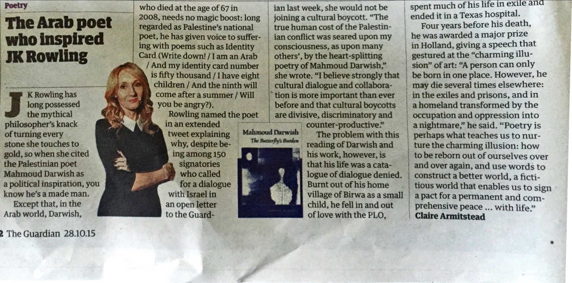

Poetry
The Arab poet who inspired JK Rowling
who died at the age of 67 in 2008, needs no magic boost: long regarded as Palestine's national poet, he has given voice to suffer: ing with poemssuch as Identity | Card (write downl/iaman Arab
নিজৰ দক্ষ, she would not be
joiningacultural boycott. “The truehuman cost of the Palestinian conflict was seared upon my consciousness, as upon many others', by the heart-splitting
| And my identity card number poetry of Mahmoud Darwish." is fifty thousands I have eight she wrote. “I believestrongly that children/And the ninth will cultural dialogue and collaboraKRowlinghas come after asummer/Will i tionismore important thanever longpossessed you be angry?). before and that cultural boycotts the mythical Rowlingnamed the poet are divisive, discriminatory and philosopher's knack inan extended - counter-productive” of turning every tweetexplaining M** The problem with this stone she touches to why, despite be “”* reading of Darwish and gold, so when she cited ingamong 15o his work, however, is the Palestinian poet signatories thathis life was a cata
Mahmoud Darwishas apolitical inspiration, you know he's a made man. Except that, in the Arab world, Darwish,
who called fora dialogue with Israelin an open letter to the Guard
* The Guardian 28.10.15
Burnt out of his home
child, he fellinandout oflove with the PLO,
a nightmare” he said. “Poetry is perhaps what teaches us to nur
logue of dialogue denied.
spent much of his life in exile and ended itinatexas hospital. Four years before his death, he was awarded a major prize in Holland, giving aspeech that gestured at the “charming illusion” of art: “Aperson can only bebominoneplace. However, he may dieseveral timeselsewhere: in the exiles and prisons, and in a homeland transformed by the occupation and oppression into
ture the charming illusion: how
to be reborn out of ourselves over
and over again, and use words to constructabetter world, a ficti
-
| tious world that enables us to sign village of Birwaas a small
a pact fora permanentand com
prehensive peace... with life.” ClaireArmitstead

