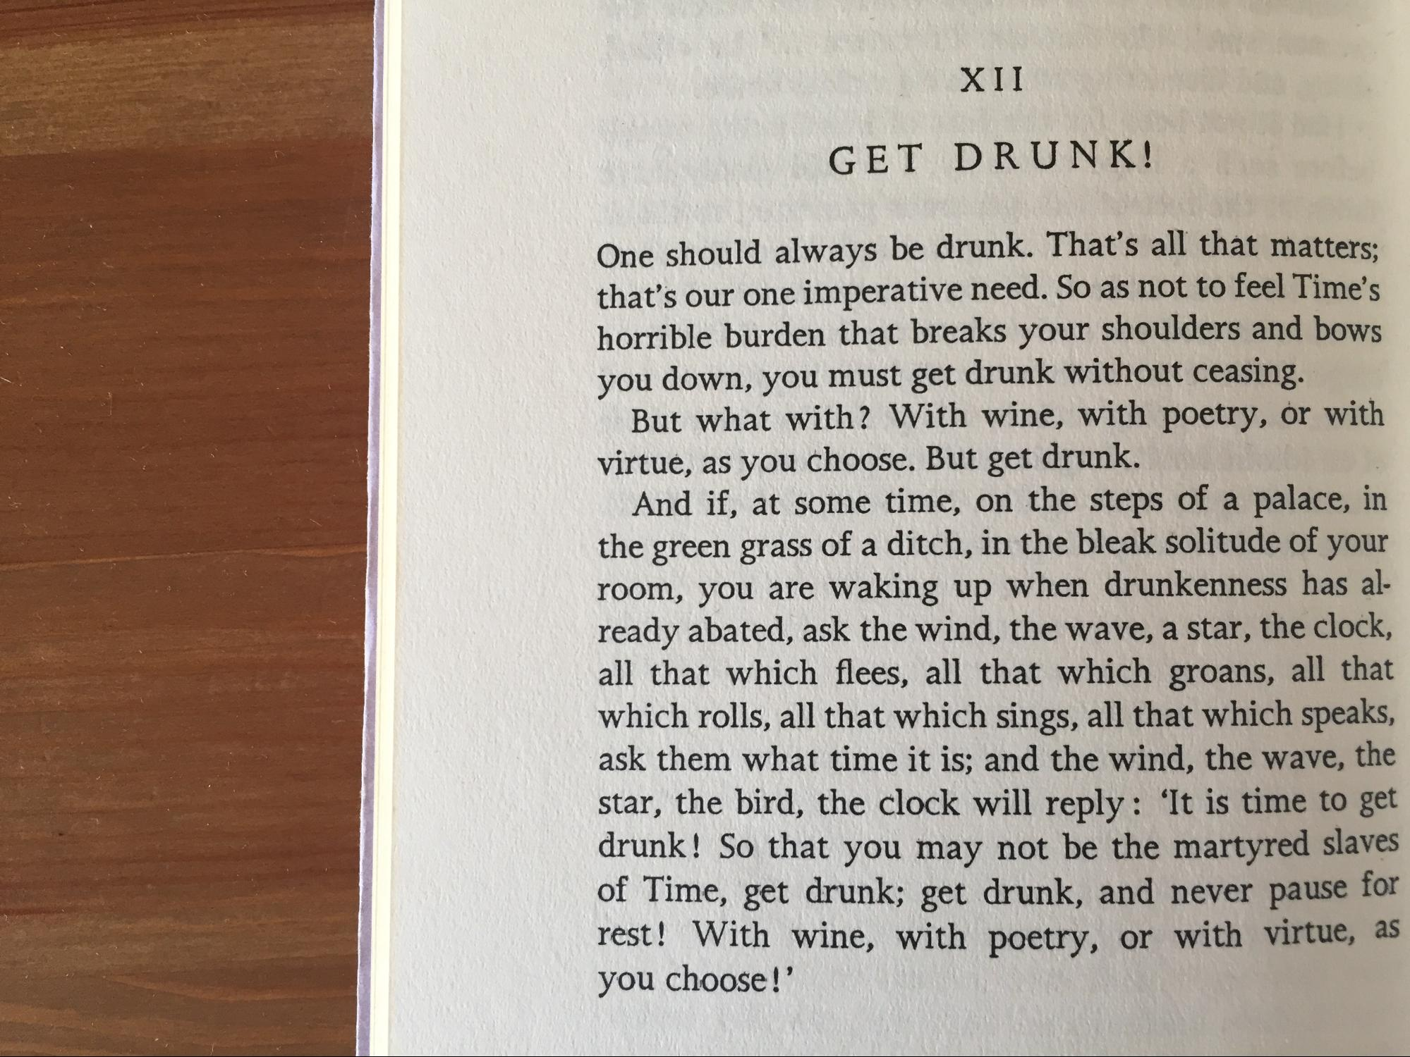

X II
G E T D R U NK
One should always be drunk. That's all that matters. that's our one imperative need. So as not to feel Time's horrible burden that breaks your shoulders and bows you down, you must get drunk without ceasing.
But what with ? With wine, with poetry, or with virtue, as you choose. But get drunk.
And if, at some time, on the steps of a palace, in the green grass of a ditch, in the bleak solitude of your room, you are waking up when drunkenness has already abated, ask the wind, the wave, a star, the clock, all that which flees, all that which groans, all that which rolls, all that which sings, all that which speaks, ask them what time it is; and the wind, the wave, the star, the bird, the clock will reply: ‘It is time to get drunk! So that you may not be the martyred slaves of Time, get drunk; get drunk, and never pause to rest! With wine, with poetry, or with virtue. " you choose!”

